**FINAL EXAMINATION**

**Instructions**

Answer all questions in section A and any five in section B

1. **What do you mean by project management?**

[**Project management**](https://www.workfront.com/solutions/project-management-software) is the planning, delegating, monitoring and control of all aspects of the project, and the motivation of those involved, to achieve the project objectives within the expected performance targets for time, cost, quality, scope, benefits and risks.

**Project management** is about knowing exactly what your goals are, how you’re going to achieve them, what resources you’ll need, and how long it will take you to reach that specific goal. In fact, project management’s goal is to make sure that everyone involved in a project knows these and is aware of the purpose of the project.

1. **Bring out the responsibilities of project manager.**

The Project Manager is responsible for delivering the project, with authority and responsibility from the Project Board to run the project on a day-to-day basis.

**Role of the project manager**

The project manager is the individual responsible for delivering the project. The individual leads and manages the [project team](https://www.finance-ni.gov.uk/articles/roles-and-responsibilities-programme-or-project-team), with authority and responsibility from the [project board](https://www.finance-ni.gov.uk/articles/roles-and-responsibilities-project-board), to run the project on a day-to-day basis.

The project manager has an important role in interfacing between the project and the business area. This is important for [communicating](https://www.finance-ni.gov.uk/articles/programme-and-project-management-communication) and encouraging the need for transformation and [change](https://www.finance-ni.gov.uk/articles/programme-and-project-change-management) within the business area in tandem with the delivery of new capabilities from the project. The readiness of the business to exploit the new capability is crucial to success. Without this state of readiness in the business, there are likely to be disruptions and delays in the plan for [benefits realization](https://www.finance-ni.gov.uk/articles/programme-and-project-benefits-management).

**Specific responsibilities of the project manager**

The project manager, operating within agreed reporting structures, is responsible for:

* managing the production of the required deliverables
* [planning](https://www.finance-ni.gov.uk/articles/programme-and-project-planning) and monitoring the project
* adopting any delegation and use of project assurance roles within agreed reporting structures
* preparing and maintaining [project, stage and exception plans](https://www.finance-ni.gov.uk/publications/templates-programmes-or-projects) as required
* managing project [risks](https://www.finance-ni.gov.uk/articles/programme-and-project-risk-management), including the development of contingency plans
* liaison with [programme management](https://www.finance-ni.gov.uk/articles/roles-and-responsibilities-programme-manager) (if the project is part of a [programme](https://www.finance-ni.gov.uk/articles/programme-management)) and related projects to ensure that work is neither overlooked nor duplicated
* monitoring overall progress and use of resources, initiating corrective action where necessary
* applying change control and [configuration management](https://www.finance-ni.gov.uk/articles/programme-and-project-configuration-management) processes
* reporting through agreed lines on project progress through [highlight reports and end-stage assessments](https://www.finance-ni.gov.uk/publications/templates-programmes-or-projects)
* liaison with appointed project assurance representatives to assure the overall direction and integrity of the project
* maintaining an awareness of potential interdependencies with other projects and their impact
* adopting and applying appropriate technical and [quality](https://www.finance-ni.gov.uk/articles/programme-and-project-quality-management) strategies and standards
* identifying and obtaining support and advice required for the management, planning and control of the project
* managing project administration
* conducting a project evaluation review to assess how well the project was managed
* preparing any follow-on action recommendations

In construction projects the  project manager also provides the interface between the project sponsor and the supply side of the project team.

1. **How budgets are framed in projects?**

**What is a Project Budget?**

A Project Budget is the total amount of monetary resources that are allocated for particular goals and objectives of the project for a specific period of time. The purpose of project budget management is to estimate and control project costs within the approved budget and to achieve the stated goals of the project.

Project budget management is a process of formally identifying, approving and paying the costs or expenses incurred on the project. Project budget management involves using purchase order forms to state each set of project expenses, such as training, consulting services, equipment and material cost, etc. Usually in the process, the project manager plays the role of “Approver” (a person who approves a budget for a project) and the finance unit (e.g. Finance Department) acts as a “Recorder” (an organizational unit that tracks and audits budgeting activities and reports to the project manager). Project budget management engages the performing organization in defining the roles and responsibilities of all parties involved in managing budget activities by undertaking the process of determining budget.

**Budgeting Process**

The process of determining budget for a project is an activity of aggregating the cost estimates of individual activities, or a work package, to develop the total cost estimate that allows setting a formal cost baseline. This baseline is used to state the budget. However, the budget may differ from the formal cost baseline and constitute the funds authorized to perform the project and its activities. The purpose of the process is to authorize and allocate the monetary resources necessary to complete all project activities and deliver the project on schedule. The main output of the process is a set of monetary resources requirements that serve as a foundation for estimating and controlling the budget and provide valuable data to the project resource management process.

The project budgeting process is conducted at the initial steps of project planning, and typically it is performed in parallel with the project scheduling process. The steps of the process are highly dependent upon the cost estimations, task durations and allocated resources. The process is also knows as “the project budgeting process”. The budgeting serves as a cost control mechanism that allows comparing actual project costs to the items of the authorized project budget.  The process allows developing a budget considering key cost factors associated with time durations of project tasks.

When working on the project budgeting activities, the project manager should collaborate with people responsible for managing the work efforts as well as for estimating project costs (the cost estimating team). They will develop and give the cost estimates of individual activities, or work packages, so that the project manager can actually start performing budgeting activities. The project manager should use the Work Break Down Structure (WBS) of the project, the costs estimates, historical data and records, resource information, and policies in order to identify the monetary resources required for the project. This statement refers to the steps of the project budget determining process. The steps are listed below:

* Using the WBS. The project WBS provides a decomposition of the project work and shows relationships between all the project deliverables and their components. The project manager should investigate the project work decomposition to see the dependencies between the work items, as well as use WBS dictionary to get the identification of the project deliverables and the description of each WBS component that are approved to produce the deliverables. Then the project manager needs to work with the cost estimating team to receive cost estimates per work package of the WBS. The obtained information will then be used for aggregating cost estimates and setting the cost baseline.
* Reviewing Historical Data and Lessons Learned. Budgeting activities from previous projects can bring more benefits to current project than it might have been expected. As being a planner, the project manager needs to review records and historical data of the previous successful projects and look for tools, methods and techniques that have made these projects succeeding. Cost estimates, WBS examples, resource allocation, estimating methods, members of the estimating team, budget control tools, etc. obtained from successfully completed projects – all this valuable information should be collected and examined, then sorted and filtered, and finally specific solutions and ideas for managing budgeting activities should be generated, considering the critical success criteria and factors.
* Investigating Resource Information. At this step, the project manager in collaboration with the estimating team should collect and investigate information on available resources, including human resource, equipment and materials. After the investigation of the resources a description of resource availability is to be created and then used for estimating costs.
* Following Project Policies. The project manager should review existing standards and requirements stated in project policies.

The implementation of the project budget determining process requires some initial information that is called “inputs”. Such inputs will be used as a foundation for taking the listed process steps. The following budget determining inputs can be considered:

* Activity Cost Estimates provide a cost estimate for each work package (a set of individual activities) within the WBS.
* Estimates Basis shows all details on cost estimates and specifies the basic decisions regarding the inclusion or exclusion of indirect project costs.
* Scope Baseline includes the scope statement, the WBS and WBS dictionary allowing determining the project budget in accordance with the cost estimates per work package.
* Project Schedule is a component of the project management plan and it reflects planned start and finish dates for the project activities, milestones, time-frames for individual activities and work packages, and auditing calendars. The information in Project Schedule is used to develop a cost schedule that indicates when the costs are planned to be incurred.
* Procurement Contracts are used to determine the project budget considering all costs incurred and associated with products and services purchased from vendors and suppliers.
* Resource Calendars are used to investigate information on resource assignments and allocation of working time assigned to the resources.

**Budgeting and Risk Management**

The budgeting process will not be complete and effective if no risk assessment and assignment have been applied. Without assessing risks surrounding the project, uncertainties and threats that happen regularly during the project implementation will affect the project’s bottom line. Cost estimates should be developed with reference to conducted risk assessing activities, but identified risks should not be considered a factor influencing the sales mark-up. Risk assessing activities allow representing risks as actual costs incurred over the course of project development. Usually risk assessment cover such areas as development team experience, reliability of the technology used, time shortages, availability of project resources, etc.

Once you have identified and analyzed your risks, you can assign a scope and percentage to each identified risk. For instance, in your project you develop a software application and you have decided to build its main component in Java and some modules C. Your team of developers is mainly experienced in Java programming, so the C component of the application software may have a higher risk assignment under the “Developer Experience” risk item. The higher percent of the risk assignment should be applied only to the relevant part of your project.

Despite the kind and size of your software development project, normally the overall risk assessment can be an amount between 25 and 30 percent of the total project cost. Without considering peculiarities of your project, you cannot say for sure that this amount is either high or low. Your actual total risk percentage will depend on the experience of your team in developing the application software in Java and C. You can look into previous projects performed by your team of developers and check if they actually fell within the available budget. If so, you may consider giving a “little credit” to your team members so that they will do current project having more opportunities for success and less risks of failure. If not, your team may be justified because your current project is not started yet so you have time for training your team before presenting and approving the project budget.

**Budgeting Process Output**

The process results in the following:

* Cost Performance Baseline. The process allows setting the cost performance baseline that gives a formal time-phased budget for estimating, tracking and controlling the overall cost performance of the project. The cost performance baseline is an aggregation of all budgets approved by time period.
* Project Funding Requirements. The process results in identification of the requirements for the total project funds. The cost baseline and the management contingency reserve amount will be covered by the requirements.
* Project Document Updates. The process of project budgeting is a critical activity that involves updates of relevant project documents, such as Project schedule, Risk Register, project cost estimates.

1. **Write a note on Break Down structure.**

The work breakdown structure is a project management classic, it’s a visual tool that’s used in the planning phase of the project. It allows project managers to break down or divide the project into more manageable parts and gives priority to the deliverables required to complete the project.

The WBS inputs consists of:

* Project Scope Statement: a detailed description of the project deliverables and the work needed to create them.
* Statement of Requirements: a detailed description of what will be delivered.
* Organizational Process Assets:  a document that includes the organization's policies, procedures, guidelines, templates, plans, lessons learned from previous projects.
* Project scope management plan: a document that will help understand how to deal with changes to the project’s scope. This document is important because these changes can impact your deliverables.

WBS is a hierarchical decomposition of the project into phases, deliverables, and work packages. It is a tree structure, which shows a subdivision of effort required to achieve an objective (e.g., a program, project, and contract).

In a project or contract, the WBS is developed by starting with the end objective and successively subdividing it into manageable components in terms of size, duration, and responsibility (e.g., systems, subsystems, components, tasks, subtasks, and work packages), which include all steps necessary to achieve the objective.

The WBS creation involves:

• Listing all the project outputs (deliverables and other direct results)

• Identifying all the activities required to deliver the outputs

• Subdividing these activities into sub activities and tasks

• Identifying the deliverable and milestone(s) of each task 107

• Identifying the time usage of all the resources (personnel and material) required to complete each task.

The purpose of developing a WBS is to:

• Allow easier management of each component

• Allow accurate estimation of time, cost, and resource requirements

• Allow easier assignment of human resources • Allow easier assignment of responsibility for activities

1. **Explain the methods of scheduling projects.**

**Project schedule methods.**

Planning and scheduling are crucial for any project, from simple jobs like roof replacement to complex endeavors such as building a skyscraper. No matter what the project, it is important to know what needs to be done (planning) and when it needs to happen (scheduling). Equally important to know is how to accomplish this process. The sections below provide some insight and examples of planning and scheduling a construction project.

## Project Planning

In its most basic form, project planning consists of determining the milestones of the project and outlining the individual tasks that need to occur in order for the milestones to be completed. For example, one milestone during construction of a residence is completion of the building foundation. The construction of the foundation can be broken down into individual subtasks such as:

* Clearing the building site
* Excavating the soil to foundation depth
* Placing reinforcing bar and creating forms for the upcoming concrete pour
* Pouring and finishing the concrete
* Providing a concrete curing period
* Removal of the concrete forms

All of the above tasks need to occur in the specific order listed in order for the foundation to be built. A length of time, or duration, will be established for each sub task so that the overall time frame required to complete the foundation can be determined. The duration for completing specific tasks is usually established based on past experience or by using references such as construction estimating manuals. Once the order of tasks is established and the duration selected for each, a construction schedule can be created. Some of the more common techniques for construction scheduling will be covered below.

## Critical Path Method

The critical path method, abbreviated as CPM, is the most commonly used type of scheduling technique in the construction industry. The critical path method is built around the use of predecessors and successors for each construction task needed to accomplish the job. Most tasks (except the initial task) will have one or more predecessors that need to be accomplished before that task can start. If we select a certain task, such a framing a house, we need to determine what must occur before the framing can be constructed. In this case the ground floor slab will need to be finished before the framing can be placed on top of it. Therefore, creation of a ground floor slab is the predecessor of the house framing task. Conversely, framing the house is a successor of the ground floor slab construction.

Following the placement of tasks in the schedule, along with the creation of linkages between the predecessor and successor tasks, a **critical path** will become apparent. The critical path is formed by the longest chain, time wise, of interrelated tasks from the project start to the project finish. Basically, if any of the tasks in the longest chain were to take longer than their planned duration, the length of the project would be extended. The extension happens because the schedule slippage in one component in the critical path will push back the start dates of that component’s successor tasks. Therefore, the project manager places a high priority on these critical tasks, in order to keep the project on schedule.

Tasks that are located off of the critical path will often contain what is known as float. Float is an important concept, and is basically spare time contained within tasks that are located outside of the critical path. For example, the installation of a building roof may be scheduled for four weeks but in reality it is only expected to take three weeks. The extra week is float contained within that task, and the actual duration of work may “float” within that time period, sliding backwards or forward as needed to accomplish the project goals. If a project task that contains float happens to run over schedule, it can use the float time to finish and not affect the completion of the overall project.

## Resource Oriented Scheduling

A scheduling technique known as **resource oriented scheduling** may be used in projects where there is competition between tasks or components for project resources. Resources may be comprised of:

* Materials such as water or cement
* Specific labor types such as welders or machine operators
* Transportation resources such as access to construction elevators or cranes.

Attempting to implement a CPM approach to scheduling when resources are limited is not always effective. A better approach may entail breaking the project in time periods or phases and calculating the resource demand during each phase. This would be followed with planning the application of the available resources to fill in the demand. Often, the layout of the initial schedule will expose resource gaps in the project. This provides the project manager with knowledge regarding the tasks that will require supplementation of existing resources or the transfer of excess resources to another portion of the project.

## Visual Depiction of Schedule: Gantt Chart

Project schedules are most commonly depicted through the use of Gantt charts. Gantt charts break down the project into individual tasks, each of which is represented by a horizontal bar. The timescale of the project travels from left to right, with the left edge of the bar representing the start date of the task and the right edge of the bar representing the completion date. The bar length between the start and the end makes up the duration of that specific task. Arrows are typically drawn from the end of one task to the start of another task that is dependent on the task that proceeded it (predecessor to successor). Similar to the CPM method above, a critical path will become apparent based on the duration of the various linked project paths. Creation of a Gantt chart is relatively simple using commonly-available software, and the chart is easily modified during construction if needed due to unforeseen events or owner-driven changes. If the chart is set up correctly electronically, with the predecessors and successor links intact, the entire project schedule will adjust accordingly when the duration of one or more tasks is modified.

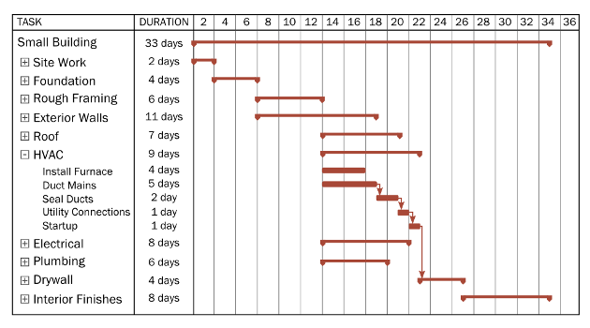

1. **What is expediting in project management?**

## THE AIM OF PROJECT EXPEDITING

The aim of the project expediting program is to control procurement for maximum advantage to the Owner.

Expediting is concerned with everything in the procurement chain:

* Preparation of specifications and inquiries.
* Evaluating and selecting vendors and preparation of purchase orders.
* Provision of technical information to vendors.
* Approvals.
* Scheduling vendors' engineering, procurement, fabrication, assembly, test and shipping.
* Measurement and reporting of vendors' progress.
* Arranging for remedial action.

The expediting program should pay particular attention to identifying in advance potential threats to the project and to arranging also in advance agreed plans of action aimed at minimizing risks due to:

* Shop overload and/or poor vendor engineering, procurement and production control methods.
* Breakage during fabrication or machining.
* Damage in transit.
* Malfunction at start-up due to inadequate inspection.

# **RELATIONSHIP OF EXPEDITING TO PURCHASING**

# Of the three elements of project execution, none has a more profound effect on timely completion than procurement. Almost invariably it is the long-delivery items of equipment which control project length, and the Project Manager's ability to control project length clearly depends on his ability to control procurement. If he loses the initiative in the procurement program his efforts to maintain close control over engineering and construction will be meaningless.

# The Project Manager's principal means of controlling procurement lies in his expediting program. As this is primarily time-oriented it is a matter for planning,

# scheduling and project control, hence is of direct concern to the Project Control Engineer.

# We consider traditional expediting methods inadequate and recommend that special procedures, as described herein, are used. Expediting is usually under the general direction of the Project Controller rather than the Purchasing Agent; the latter remains intimately involved with all aspects of procurement including expediting, but is more concerned with the contractual than with the scheduling, measuring, reporting and control activities which together constitute the expediting program.

# **EXPEDITING PHILOSOPHY**

# The underlying philosophy for expediting is that the Project Manager should be able to control procurement effectively at all times. This means he must know the status of all procurement action and must be able to judge its effect on the project as a whole. He must have early warning of incipient difficulties. Above all he must be prepared to act quickly and decisively to restore any situation which threatens achievement of his objective. For him to do this, the means to evaluate procurement status and to take action must be built into the procurement program from the start. The Project Manager cannot afford to leave the initiative in the hands of the vendor, the Purchasing Agent, the Project Controller or others. It is imperative that he take a direct and personal interest in project procurement affairs delegating responsibility where necessary but keeping himself effectively "in the picture" at all times.

# Because of the extent and complexity of most project procurement programs, it is seldom practicable for the expediting program to cover: all items in equal detail and expediting action must therefore be on a selective basis, with greatest emphasis on critical items and progressively less emphasis on those items which are either not needed for start-up or which, even if late, will still arrive in plenty of time.

# There is sometimes a mistaken belief that adequate protection against procurement delays can be achieved through penalty or bonus-penalty clauses. Our philosophy is that such clauses are of little value and that satisfactory protection can be achieved ONLY by:

# Building the means to schedule, measure and control procurement progress into inquiries and. purchase orders.

# Careful evaluation of bidders' ability to schedule and control production, and award of purchase orders not merely on the basis of price or of a Sponsor preference, but only after careful inspection and evaluation of bidder's premises and of recent performance.

# Pursuing a vigorous (though selective), comprehensive and common sense expediting program aimed at controlling vital procurement.

# Focusing expediting attention and reporting not on what has already been accomplished, but on what remains to be accomplished and the difficulties extant or anticipated which actually threaten the project objective.

# Bold, timely and decisive action on the part of the Project Manager to correct any situation which poses a significant threat.

# **RESPONSIBILITY**

# Responsibility for expediting rests with the Project Manager but may be delegated all or in part to other members of the Task Force depending on workload, personalities and experience. Expediting is time consuming and there is a danger that if it is delegated to someone who’s other duties is also time consuming, neither expediting nor the other duties will be performed satisfactorily. For this reason, it is important that responsibility for expediting is delegated with great care. On occasion it may be necessary to hire special expeditors; where this occurs special care is needed in their selection.

# Other members of the Task Force and may also be called upon to act as project expeditors responsible for certain portions of the work. It must be clearly understood that notwithstanding such arrangements expediting responsibility remains with the Project Manager or his delegated Expediting Coordinator.

# **THE EXPEDITING PLAN**

# This results from a study of the procurement program, project priorities, project schedule, geographic location of vendors and expeditors, expediting manpower needs and resources. The plan consists of:

# A list of procurement items by categories.

# Vendor's name and location for each item.

# Name of expeditor assigned to each item.

# Expediting categories are as follows:

# CATEGORY A.

# Items the Owner needs to obtain a return on investment from products for which he has an immediate market. This includes only those items where any delay whatsoever will seriously affect return on investment.

# CATEGORY B.

# Items the Owner needs to obtain a return on investment from products for which there is an immediate market but where there is no immediate equipment delivery problem. However, should serious delays develop these items will become critical and will be re-classified Category A.

# CATEGORY C.

# Items for which the Owner has no urgent need but which control overall project length and if delayed will result in unnecessary task force and overhead expense.

# CATEGORY D.

# Items for which the Owner has no urgent need and which do not control overall project length but are needed to maintain schedule in individual area installations and start-ups.

# CATEGORY E.

# Items for which no expediting action appears necessary at this time.

# Initially all components of a procurement item are assigned the same category, but as more specific information arrives many can be down-graded so that Category A contains only those items which are actually crucial from the Owner's point of view. On the other hand, some items must be up-graded because of delays, and the Project Manager must insist that the Expediting Plan is reviewed frequently.

1. **Explain the methods of data collection.**

Collecting requirements for a project is a very vital part. In fact, collect requirements process helps to define project scope during scope management. There are some set of tools and techniques to gather project requirements. It seems practical to collect all requirements at the start using a requirement-gathering tool. This should ensure the project deliverable as sought. But in reality, it is more challenging in present scenario – Why? The reason is, today’s scenario is dynamic in nature. Needs and requirements of project stakeholders change frequently. So, it's a responsibility of Project-manager (PM) to ensure capturing all the requirements. PM needs to be very agile while collecting requirements. To do so, PM should use appropriate requirement gathering tools during the project life. PM needs to be wise in the selection of the requirements tools. PM would ensure not to miss any requirement in the project outcome. Because, in the end, PM is liable for the success of the project. Consider yourself and ask these questions.

* How many projects have you not been able to succeed due to requirement issues?
* Have you faced challenges in gathering project requirements?
* How well are you in translating stakeholders’ all needs into project deliverables?
* Do you always use your favorite requirement collection technique irrespective of situation?

**Project Management Collection requirement process:**

Project Requirement:

Let’s first define Requirements in a Project. The requirement is the expectation of project stakeholders on project outcomes. As per the definition is given by PMI, “Collect Requirements is the process of determining, documenting, and managing stakeholder needs & requirements to meet project objectives."

In Collection requirement process, the first step is to identify stakeholders’ needs. Second, Document these needs & requirements. And then, manage them throughout the project to meet project goals. This process forms the basis for project scope definition.

This process contributes to the success or failure of a project. As per PMI, about 70% project’s failure is attributed to requirement collection. Also, this failure ranges from 50% to 70% depending on industry and type of project. A shocking fact, most of these projects were meeting schedule & budget criterion well. Product conflict was observed during final project delivery or project closure phase. Where project product couldn’t meet stakeholder’s requirements. So, now you can imagine, how much impact this process has, on project success!

Project Management tools and techniques for requirement gathering:

For any project success, project result must meet stakeholder’s needs and expectations. Capturing all project management requirements keeps you one step closer to project success.

1. **Expert Judgment:**

Experts are the people more knowledgeable in their respective areas. Their knowledge & experience help to gather most of the specific product/ project requirements. Expert judgment is used to determine specialized requirements comprising following topics:

* Requirements elicitation
* Requirements analysis
* Business analysis
* Diagramming techniques
* Facilitation
* Conflict Management
* Projects requirements in similar previous projects

2. **Data Gathering:**

Data gathering is an important technique for facilitation &/or group creativity. Example (a group of people involves figuring out all project requirements. Ideas evolve through group creativity and help to determine requirements). There are several tools, we can use this technique. But the right selection depends on the type of needs or stakeholders including other complexities. Below is the list of tools under this technique:

**a) Questionnaires and Surveys:**

We use this requirement-gathering tool for large groups. Wherever there is a need to capture the requirements from various stakeholders. A large number of stakeholders doesn’t permit to arrange a one-to-one interview. Also, it’s not wise to call all them at one place, if they sit remotely. So, Questionnaire & Surveys give the opportunity to collect requirements of a big group of stakeholders. It also provides flexibility to stakeholders to take part as per their ease. Yet, to prepare the survey questions is another challenge, you have to be very careful about. Framing right/ relevant questions remove bias & help to collect real needs of stakeholders

**b) Interviews:**

A tool to engage personally with stakeholders to understand needs. Interviews can be facilitated through personal meetings or phone calls. It’s a good practice to prepare a checklist before interviewing. This will ensure to capture all the requirements in a single meeting. Interviews can be elaborative; hence gives an opportunity to understand stated or unstated needs.

**c) Focus groups:**

It’s used, when we want to collect the needs from specific sets of stakeholders. Suppose you need to gather the needs of the top executive and process owners both. You can schedule separate meetings with the two. And gather the individual group's requirements.

**d) Brain Storming:**

Also called as group thinking or group creativity. It evolves several new ideas and new requirements. People from different domains and functions come together for a meeting. They try to share their ideas and requirements with creative thinking. This technique is very useful when you don’t have any preset need. And you try to explore new requirements for a new product.

**e) Benchmarking:**

In this technique, the comparison is made between existing practices & best practices. This way most of the organizations try to explore best in class practices. And hence set their requirements to improve their current position. As we know, a market is more dynamic than ever. It is full of competition. So, to be in a race and maintain market positioning, organizations go for benchmarking. And with gap analysis, they explore the requirements and take projects.

3. **Data Analysis:**

Business analyst often uses these techniques. This technique is also known as Document analysis. As the name suggests, we analyze existing documents to elicit project requirements. This technique utilizes documents like:

* Business plans,
* Use cases,
* Problem or issue logs,
* Policies or procedures,
* Business rules repositories and/ or
* Market literature etc., to elicit requirements.

4**. Decision Making:**

Following are the techniques used in decision making for requirements collection:

**a) Multi-Voting:**

It is further divided into 3 categories:

* Unanimity: All group members agree to a final decision. Hence, there will be unanimity among group members about final requirements.
* Majority: Here, more than 50% of the members in the group agree to final decision.
* Plurality: The larger chunks of votes in a group qualify as a final decision. For an example, if 60% of the people agree, 25% of the members disagree and rests are neutral. Then, a final set of requirement goes with 60% votes in agreement.

**b) Multi-criteria decision-making:**

Here, multiple criteria are set before making a decision. These criteria are assigned different ranks. To reach final requirements, calculate these ranks. Give priority to the higher rank.

**c) Autocratic decision-making:**

Also called as dictatorship group decision-making. Here, only one individual defines the requirements. Who doesn’t take any consensus from others? For example, Top executive of the organization only sets the project requirements.

**5. Data representation:**

Following tools are used in this technique:

**a) Affinity Diagram:**

It is used, when we have a large number of stakeholders requirements. A similar set of requirements, we can group together under one head. Hence, we reduce the number of requirements to least possible few categories. This broadens the scope of focusing few categories rather than taking all them at once.

**b) Mind Mapping:**

Here, we wear the caps of different stakeholders. Try to map their minds and generate ideas. Thus, it’s a technique to generate a large number of ideas through the process of backtracking. A very useful technique to identify the requirements of potential customers or end users.

**6. Interpersonal and team skills:**

**a) Nominal Group Technique:**

This technique is generally used to prioritize the requirements. Here, all stakeholders take part in a brainstorming session. Generate as many ideas through brainstorming. Then rank for each idea generated. Add up all these ranks from each stakeholder to get the final ranking of each idea. These ideas are then sorted out to gather most important requirements. Higher the rank, higher the priority.

**b) Observation:**

Also known as a job – shadowing. Here, a potential user or group of users is observed for identifying requirements. E-commerce sites use this technique to identify the patterns of customer’s needs.

**c) Joint Application Design & Development:**

This technique is more focused on group dynamics & synergy. Introduced by IBM in the late 1970s, it brings stakeholders from various domains together. Commonly, referred as JAD, this technique is held in 3-4 sessions. All relevant stakeholders are invited to these sessions to gather requirements. They discuss and come to a consensus to set final requirements.

**d) Quality Function Deployment:**

Also known as a house of quality. This technique is preferred to generate technical requirements when stakeholders’ needs are known. Translate voice for stakeholders to identify process requirements.

**e) User Stories:**

Capture user’s experiences to identify different needs. Nowadays, social platforms provide many opportunities to gather user’s experiences. Examples are Twitter and Facebook etc.

**7. Context Diagram:**

Context diagrams exemplify a scope model. They represent a pictorial visualization of various interactions. Interactions between different users and system. Thus, they depict the steps – customers & processes take, to result in system outcomes.

**8. Prototypes:**

A model of the final product is developed based on stakeholders’ need. Now, stakeholders are asked to give their feedback on this model. Negative feedbacks are captured to identify further requirements. Positive feedbacks are retained as it is. Thus, prototype gives the flavor of the final product in advance.

**9. Delphi technique PMP:**

What is the Delphi technique in project management? Delphi technique is used to capture stakeholder’s needs free from any bias or influence. Stakeholders with different level of influence are requested for information anonymously. All these requirements are collected and analyzed. Collected results are then shared among stakeholders. This way, it reduces the chance of not affecting any process stakeholders need for Top executive’s.

**10. Facilitated Workshops:**

This technique is like JAD sessions. Invite stakeholders with across different perspectives and interests in a common workshop. A facilitator helps them to bring consensus before freezing final requirements. Generally, people from cross-functional areas take part in these facilitated workshops.

1. **What is auditing?**

Conducting an audit is imperative to assess the progress of a project and regular audit sessions ensure that a project’s management is in-sync with the established project objectives. Ideally, an audit process should have some level of flexibility. The reason – various teams and organizational resources are involved in the execution of a project and to measure each of them using a standard assessment tool may not provide the most accurate results. However, the focus should be on not deviating from the purpose of a [project management](https://www.brighthubpm.com/monitoring-projects/1955-developing-a-good-project-management-methodology/) auditing process – it is an honest assessment of team and individual performances and their ability to execute assignments to achieve project targets, both short-term and long-term.

A basic checklist that is often used for auditing project management to assess the Project Characteristics includes verifying the presence of:

* Strategic project management tools for organizing and monitoring every facet of a project
* Clearly-defined phases and sub-processes through a project’s lifecycle
* Delegation of responsibilities to ensure that each of the project phase is in agreement with the critical project objectives

Conducting periodic audits ensures that project-related risks are avoided.

Usual risks that hinder project performance are:

* Practices that defy cost-management and make the project economically unfeasible
* Non-adherence with the project plan or organizational practices
* Inability to keep-up with time-specific deadlines
* Over or under-evaluation of availability of resources
* Presence of team personnel who are not qualified for the project

Every organization has various [project-related processes](https://www.brighthubpm.com/project-planning/19689-real-life-project-management-process-examples/) and each of them needs to be audited. Following are some of processes and auditing-related queries that are designed to judge their overall performance:

## Auditing of Cost-related Processes (Including Financial Planning)

**Budget-based**

· Have the [project costs](https://www.brighthubpm.com/monitoring-projects/9676-project-constraints-cost/) been managed to ensure that they don’t exceed the defined budgetary allocation?

* Is the proposed project budget compatible with the organization’s limitations?
* Does the project budget has a scope for bearing contingency or risk-related expenses?
* Is there a budgetary review and does it highlight the reasons for budget discrepancies?

**Estimation-based:**

* Has the cost estimation process been clearly-defined and documented?
* Was cost estimation conducted in accordance with accounting regulations?
* What methods were used for estimating expenditures related to project execution?

## Auditing of Strategic Management-based Processes (Including Management of Organizational Interdependencies)

* Has the authority and the level of accountability been properly divided between various organizational entities like stakeholders, team members and customers?
* Does the management use strategic monitoring/evaluation tools like taking remedial actions, periodic reviews, establishing responsibility delegation and tracking/verification of adherence to guidelines?
* Does the project manager have acceptable levels of authority and clearly-defined accountability instructions?
* Is there a system of analyzing past projects and using this information for improving future task-related performances?
* Is there a system to manage project interaction teams like those involved in risk management, [project evaluation](https://www.brighthubpm.com/resource-management/13661-how-can-i-evaluate-a-project-resources-reliability/) and team communication?
* Does the project plan address issues such as reviews, progress reports and does it include the evaluation of various project interfaces?

## Core constituents of project management that are analyzed during an audit:

**Time Management**

* [Time schedule development](https://www.brighthubpm.com/project-planning/32495-time-management-tips-for-project-managers/) and control measures
* Activity duration analysis in terms, including inter-team dependency

[Resource Management](https://www.brighthubpm.com/resource-management/14438-key-elements-of-resource-management/)

* Resource planning and control in terms of:

Allocation of resources, criteria for distribution, analysis of consumption patterns and measures to control resource abuse.

**Personnel Management**

* Allocation of staff and establishment of recruiting policies
* Division of responsibilities regarding team development and training needs

**Information Management**

* Policies regarding Preparing and Collecting information
* Principles used for Classifying and Distributing information
* Methods used for Filing, Updating and Retrieving information

The purpose of the audit is not just analyzing various project management resources and functionalities but also to help the organization understand the performance of each of them.

1. **List out the types of organization structure in project management.**

A project operates in with people, process and technology of an organization. Projects have an impact on the culture, policies, procedures and other aspects of an organization. The organizational structure has a major influence on the execution of the project. [The organizational structure](https://www.greycampus.com/blog/project-management/which-pmo-structure-is-right-for-your-organization) decides the resources, communication methods and other aspects of project management.

Different types of organizational structures include:

**Functional**

This is the most common form of an organization. Organizational departments are grouped by areas of specialization within different functions. In these organizations, the project generally occurs in a silo environment, i.e. within the same function. Team members complete the project work over and above their responsibilities to normal departmental work. Communication primarily occurs within the same function.

**Projectized**

In a projectized environment, the entire company is organized by projects, and the project manager is in control of the projects. Individuals or employees are assigned to projects and report to a project manager. One’s the project is over, they need to be assigned to another project. Communication primarily occurs within the same project.

**Matrix**

In a matrix organization, the team members report into two bosses: the functional manager and the project manager. [Communication](https://www.greycampus.com/blog/project-management/communication-for-the-pmp) goes from team members to both bosses. The matrix organization is created to get the best potential from both functional and projectized type of organizational structure. Team members have departmental work and they also do project work.

Depending on the strength of the matrix organization, the power or level of authority varies between [the project manager and the functional manager](https://www.greycampus.com/blog/project-management/key-differences-between-product-manager-and-project-manager-and-project-leader). In a strong matrix organization, the power remains with the project manager. In a weak matrix organization, the power remains with the functional manager. The project manager is considered to be a coordinator or an escalator. In a balanced matrix, the power is equally balanced between the project manager and the functional manager.

**Smart Study**

In the [PMP exam](https://www.greycampus.com/pmp-training-instructor-led), if the organizational structure is not defined, please assume it is a Matrix organization structure. Similarly, if you see a term “tight matrix organization”, please remember it has nothing to do with matrix organization. It simply refers to locating offices of the project team in one room.

Apart from the above, there are more organization types as follows:

* Organic or simple which is a flexible organization
* Virtual, in which the project manager makes a connection to others thereby a network of people is created
* Multi-divisional, wherein functional groups are decentralized across geographies
* Note: The projectized organization is also called a project-oriented organization. Sometimes this may be derived from a composite (a mix of organization types, or a hybrid organization)

1. **Explain conflict management.**

Strong conflict management skills are an advantage in most positions, as conflict is virtually impossible to avoid. It is human nature to disagree, and disagreements are in fact healthy when approached correctly. Eliminating conflict entirely would cause its own problems: there would be no diversity of opinion and no way for us to catch and correct flawed plans and policies.

But poor communication or interpersonal tension can easily cause simple disagreements to flare up into resentment or worse. Conflicts that are allowed to fester and grow will ultimately diminish productivity and damage staff morale. This is why employers seek employees with the skills to manage and diffuse conflict.

**What Are Conflict Management Skills?**

As we have established, the aim for professionals should not be to avoid conflict, but to resolve it in an effective manner.

Individuals who handle conflict in a respectful, optimistic way create the chance for growth and learning within an organization.

Communicating clearly, empathetically, and patiently leads to favorable outcomes and keeps professional relationships strong.

**Types of Conflict Management Skills**

**Communication**

Much unnecessary conflict can be avoided simply with clear, accurate [written and verbal communication](https://www.thebalancecareers.com/communication-skills-list-2063779); a single lost email could lead to failed plans and fingers pointed. Assumptions about what other people already know, think, or intend can cause resentment or worse. Many people argue purely because they want to feel heard. Simply being a good listener can be enough to inspire trust and resolve hurt feelings. Examples of good communication skills include:

* Quickly Addressing Problems
* Understanding Reluctant Participants
* Formalizing Agreements
* [Active Listening](https://www.thebalancecareers.com/active-listening-skills-with-examples-2059684)
* [Leadership](https://www.thebalancecareers.com/leadership-skills-list-2063757)
* Mediating
* Meeting with Parties
* Modeling Reasonable Dialogue
* [Negotiating](https://www.thebalancecareers.com/negotiation-skills-list-2063760)
* Nonverbal Communication
* Open Dialogue
* Suppressing Conflict-Provoking Behaviors
* Teaching Positive Behaviors
* Written Communication.

**Emotional Intelligence**

[Emotional intelligence](https://www.thebalancecareers.com/interview-questions-about-your-emotional-intelligence-2059962) is the ability to understand one’s own feelings and those of others, and to handle those feelings well. People who have high emotional intelligence are good at identifying and meeting the needs of others while taking responsibility for their own needs and feelings. A few ways they do this are:

* Being Adaptable
* [Being Analytical](https://www.thebalancecareers.com/analytical-skills-list-2063729)
* Asserting Feelings
* Compromising
* Showing Curiosity
* Forgiving Transgressions
* Helping Others
* Identifying Triggers
* Recognizing Improvements
* Setting Ground Rules
* Showing Respect
* Modifying Behavior
* Being Motivated
* Being Optimistic
* Being Self-Aware
* Displaying Self-Regulation

**Empathy**

Empathy means feeling what others feel. The ability to see a situation from someone else’s viewpoint, and to understand their needs, motivations, and possible misunderstandings, is critical to effective conflict management. Some people are naturally more empathetic than others, but empathy can be developed.

At its most useful, empathy is augmented by an intellectual understanding of another’s situation, since emotional empathy alone can sometimes create complicated scenarios. Empathy is best applied in a work environment when paired with critical thinking, emotional intelligence, and other types of discernment. Hallmarks of empathy include:

* Accountability
* Asking for Feedback
* Building Trust
* Showing Compassion
* Embracing Diversity and Inclusion
* Giving Constructive Feedback
* Handling Difficult People
* Managing Emotions
* High Emotional Intelligence
* Identifying Nonverbal Cues
* Recognizing Differences
* Understanding Different Viewpoints
* [Good Interpersonal Skills](https://www.thebalancecareers.com/interpersonal-skills-list-2063724)
* Ability to Recognize Problems
* Good Self-Control
* Ability to Embrace Different Opinions

**Creative Problem Solving**

Understanding and communication are all very well and good, but do not help much if you don’t have a solution for the underlying problem, whatever that problem may be. Conflict often happens because no one can come up with a workable solution, so resolving the conflict depends on creating a solution. That makes [problem-solving](https://www.thebalancecareers.com/problem-solving-skills-with-examples-2063764) an in-demand skill for employers. Examples of problem-solving conflicts in the workplace include:

* Conflict Analysis
* Brainstorming Solutions
* Collaborating
* Verbal Communication
* Convening Meetings
* Creativity
* Decision Making
* Designating Sanctions
* Nonverbal Communication
* [Problem Solving](https://www.thebalancecareers.com/problem-solving-skills-with-examples-2063764)
* Sense of Humor
* Goal Integration
* Monitoring Compliance
* Reconfiguring Relationships
* Fair Resolution

**More Conflict Management Skills**

Here are additional conflict management skills for resumes, cover letters, job applications, and interviews. Required skills will vary based on the job to which you're applying, so also review our list of [skills listed by job](https://www.thebalancecareers.com/skills-listed-by-job-4161913)[and type of skill](https://www.thebalancecareers.com/list-of-the-best-skills-for-resumes-2062422).

* Apologizing
* Avoiding Punishing
* Being Present
* Calmness
* Impartiality
* Intuitiveness
* Ability to "Let It Go"
* Patience
* Positivity
* Ability to Prioritize Relationships
* Respecting Differences
* Separating Yourself
* Stress Management
* Ability to Take Criticism

**Section B**

1. **Describe the concept of work break down structure in project planning.**

A [Work Breakdown Structure (WBS)](https://www.visual-paradigm.com/features/breakdown-structure-diagram-tool/) is a deliverable-oriented hierarchical decomposition of the work to be executed by the project team to accomplish the project objectives and create the required deliverables. A WBS is the cornerstone of effective project planning, execution, controlling, monitoring, and reporting. All the work contained within the WBS is to be identified, estimated, scheduled, and budgeted.

## Work Breakdown Structure Diagram

The Work Breakdown Structure (WBS) is developed to establish a common understanding of project scope. It is a hierarchical description of the work that must be done to complete the deliverables of a project. Each descending level in the WBS represents an increasingly detailed description of the project deliverables.

The first two levels of the WBS (the root node and Level 2) define a set of planned outcomes that collectively and exclusively represent 100% of the project scope. At each subsequent level, the children of a parent node collectively and exclusively represent 100% of the scope of their parent node. Here is a Work Breakdown Structure example:

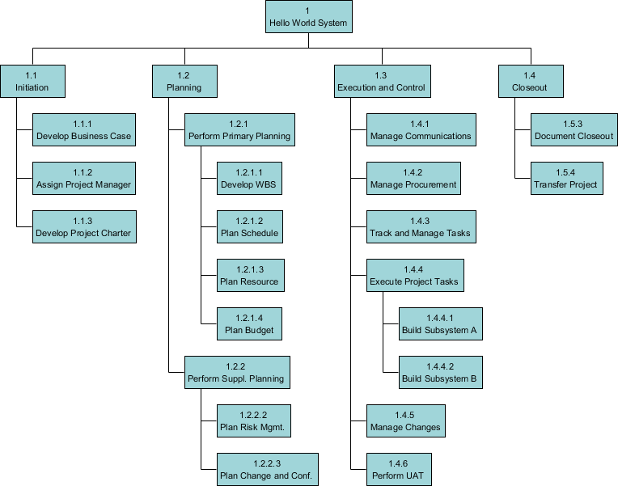

## Quality of a Work Breakdown Structures

A well-designed WBS describes planned outcomes instead of planned actions. Outcomes are the desired ends of the project, such as a product, result, or service, and can be predicted accurately. Actions, on the other hand, may be difficult to predict accurately. A well-designed WBS makes it easy to assign elements of the WBS to any project activity. A good WBS should exhibit the following characteristics:

* Definable—can be described and easily understood by project participants.
* Manageable—a meaningful unit of work where specific responsibility and authority can be assigned to a responsible individual.
* Estimate able—duration can be estimated in time required to complete, and cost can be estimated in resources required to complete.
* Independent—minimum interface with or dependence on other ongoing elements (i.e., assignable to a single control account, and clearly distinguishable from other work packages).
* Integra table—integrates with other project work elements and with higher level cost estimates and schedules to include the entire project.
* Measurable—can be used to measure progress; has start and completion dates and measurable interim milestones.
* Adaptable—sufficiently flexible so the addition/elimination of work scope can be readily accommodated in the WBS framework.

## Guidelines for Developing Work Breakdown Structure

The development of Work Breakdown Structure involves subdividing the major project activities or sub-activities into smaller, more manageable activities until the activities are defined in sufficient detail to support the management and development of project works. The items at the lowest level of a branch are known as work packages. Here are some tips in developing a Work Breakdown Structure that can express works effectively:

1. Always express Work Breakdown Structure activities at the lowest levels of granularity in verb form.
2. Review the Work Breakdown Structure. Make sure all deliverables have been fully covered by the works defined in the Work Breakdown Structure.
3. Ensure that testing and training have been taken into account.
4. Ensure that non-IT work packages are also included such as, documentation and review activities are included in the structure.
5. Ensure that other supporting activities such as, product/service launch and implementation activities are planned.
6. Ensure that delivery approval cycles are taken into account.
7. Include project management deliverables on the project as well (e.g. production of Project Plan). Include any deliverables that must be met or delivered by the customer or any external parties. Check the Work Breakdown Structure against the project approach specified in Project Charter for any activities that needs to be included in the Work Breakdown Structure.

## Different Forms of Work Breakdown Structure

Generally speaking, there are three typical ways in structuring works with a Work Breakdown Structure (WBS). They includes phase-based structures, deliverable-based structures and responsibility-based structures.

### **Phase-based structures**

Define and structure project activities based on the project phases.

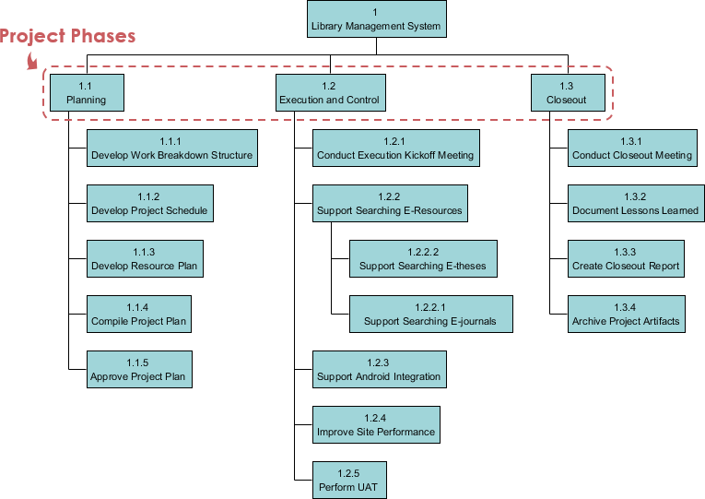

### **Deliverable-based structures**

Define and structure project activities based on the deliverables agreed to deliver.

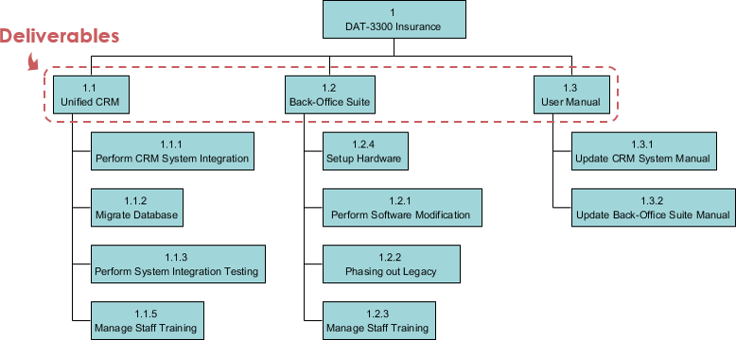

### **Responsibility-based structure**

### Define and structure project activities based on the organization units that will work on the project.

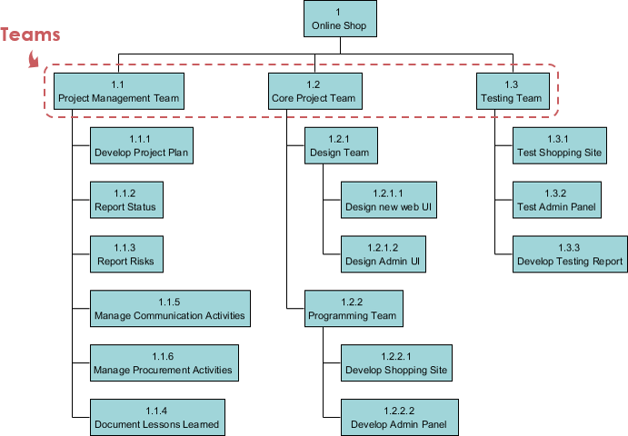

### **Other Use Cases of Breakdown Structure**

### Typical use of breakdown structure as a project management tool includes Work Breakdown Structure (WBS), Resource Breakdown Structure, Risk Breakdown Structure and Organization Breakdown Structure (OBS), or sometimes known as Organization Chart.

### Resource Breakdown Structure

### Resource Breakdown Structure (RBS) is a project management tool that provides a hierarchical decomposition of resources, either structured by resource category, types or by IT/business function that has resource needs.

### Here is a Resource Breakdown Structure example:

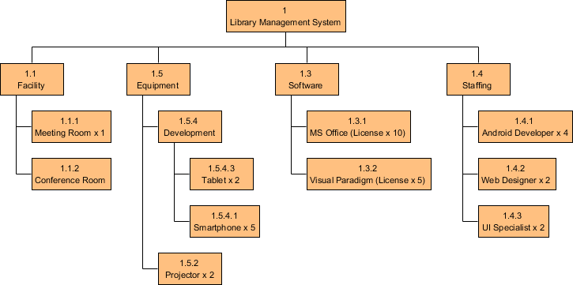

### **Risk Breakdown Structure**

Risks are everything in any IT project. The existence of risk causes negative impact on project schedule, costs and quality. In project management, Project Manager is responsible for managing risks and to ensure that the project will be delivered on time, within project and up to the standard user expected. One of the popular risk management tool is the Risk Breakdown Structure.

Risk breakdown Structure is the hierarchical decomposition of risks, starting from the root node element that represents the project, and going down to the various risk categories, and then finer level risks.

Besides presenting project risks in a Risk Breakdown Structure, it is possible to combine the use of Color Legend in representing the impact of risk. Take a look at the Risk Breakdown Structure example below, a legend of Impact with five items has been setup, representing the five levels of impacts that risks may have on the project with five distinct color code.

Here is a Risk Breakdown Structure example:

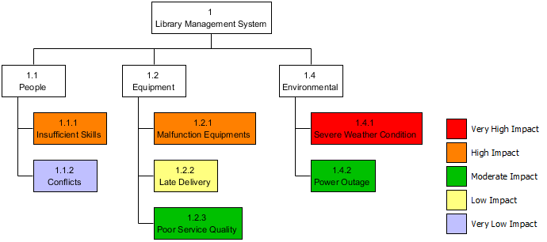

**Organizational Breakdown Structure**

Organizational Breakdown Structure, or sometimes known as Organization Chart, is a widely used project management tool for representing project organization. It typically begins with the project sponsor, and with all key stakeholders included. In presenting the organization structure, consider the organization or group that is requesting the project and the level of their sponsorship and authority.

Here is an Organizational Breakdown Structure example:

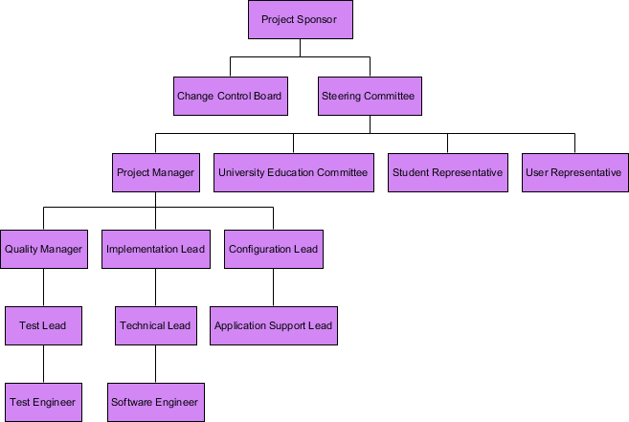

1. **What do you mean by budget uncertainty? How risk is managed in projects**

# Uncertainty in Project Management: How to reduce it?

# Project managers always try their best to conform to all the elements and avoid uncertainty in project management with the hope to ensure success in their undertaking. However, nobody can predict the future and project managers are not spared by the fact that anytime, there will be challenges that may get in the way and cause some fear and uncertainties during the project development.

# Facing uncertainty in project management

We can never be certain of the future but project managers overcome these challenges by planning ahead of time. They can start the project early so that they can address any problem that gets in the way and resolve it the soonest time possible. As the saying goes, without a plan, you are planning to fail. However, not all plans work which is why they say, if plan A fails, be ready for plan B.

At other times, proficient and experienced managers use decision milestones. With this strategy, they can anticipate possible risks and use risk management in preventing disasters from happening. However, even if these measures have been done, the project may still end up short of schedule, with excessive budget, and compromised outcomes.

## Reducing Uncertainty in Project Management

Project managers provide estimates of the project that is more than its actual estimate of completion because they include some allowances for uncertainties to happen.

While it is almost impossible to eliminate uncertainty in project management, there are ways to reduce the elements. When there are only fewer elements to be considered in the estimation, the estimate becomes more reliable, and uncertainty becomes lower.

## Coping With Uncertainty

After reducing uncertainties, it is time to take a look at the remaining factors  and check on a few strategies to use depending on the constraints.

* A fixed scope can give a fixed schedule by allocating about 30% of the schedule for uncertainties to happen.
* In high-uncertainty projects, the scope can be adjusted and commit only to the schedule as this is the only thing that can be controlled.
* In projects with the greatest uncertainty because the scope is unknown and there is no fixed schedule such as in reactive companies and departments like [customer support](https://en.wikipedia.org/wiki/Customer_support), employees are trained to handle urgent matters quickly.

## Risk Management

A project risk is an uncertainty that can be a negative or positive factor and it can affect the achievable performance to a significant extent.

[Risk management](https://www.nutcache.com/blog/the-relationship-of-risk-management-to-project-management/) involves determining those factors, planning how to avoid their negative effects or just simply accepting them if they are not affecting performance negatively.

Oftentimes, the project team draws up contingency plans for significant risks. From there, they set those plans ready and apply them when necessary.

Getting used to uncertainty in project management means learning how to manage risks — coping with uncertainty factors and reducing them. No project manager can predict the uncertainties that can happen but they can learn to gauge the uncertainty degree in the project and find ways to adapt or prevent them.

1. **How resource loading and levelling are done in project resource allocation?**

## Resource Allocation in Project Management

Project management is a very wide area of work, particularly in business. It covers many different topics which can be broken into even smaller particles. Work of a project manager is not only about giving people orders and telling them what to do. Many people limit their work of a project manager to supervising their employees and making sure everyone meets their deadline. But a good project manager knows it’s more than that.

[Resource allocation in project management](https://www.projectinsight.net/project-management-basics/basic-resource-management) is one of those particles which make work of a good PM effective and significant. And even though it may seem simple, it is actually crucial in delivering a great project.

Resource allocation in project management is concerned with creating a plan which can help achieve future goals. There are many resources which have to be allocated when managing a project, beginning from budget to equipment and tools, to data and the project’s plan.

## Why Is Resource Allocation in Project Management Important?

Resource allocation in project management is so important because it gives a clear picture on the amount of work that has to be done. It also helps to schedule ahead and have an insight into the team’s progress, including allocating the right amount of time to everyone on the team.

Resource allocation allows to plan and prepare for the project’s implementation or achieving goals. It is also possible to analyze existing [threats and risks](https://www.timecamp.com/blog/index.php/2018/02/positive-vs-negative-risk-in-project-management/) to the project.

But above all, resource allocation in project management helps to control all the workload. This, as a result, contributes to team’s effectiveness at work and what follows later is a satisfying and exhaustive project.

## How to Allocate Resources When Managing a Project?

Since resources refer to quite an extensive list of things and aspects of project management, it may be confusing when trying to properly allocate them all. But it’s not difficult and requires certain dedication and involvement. Here’s [what you can do to allocate resources in the right way when managing a project](https://www.projectmanager.com/blog/resource-allocation):

* know the scope – to know what is your project about, what you will need to achieve it, and to be able to properly allocate resources;
* identify resources – to know which tools, equipment, etc. you will need it completing the project;
* track time – to have a deep analysis of the progress and current situation as well as be able to control it in the real-time;
* don’t look only at the big picture – the process of working on a project is not done with task allocation. Once you allocate resources you have to keep track of all of them. If you lose at least one tiny detail, your project may fail;
* don’t over-allocate – because your team will experience burnout and their productivity will significantly drop.

Project allocation and leveling are both important parts of project management. Typically, they're referred to as "resource allocation" and "resource leveling." They both involve the distribution of resources -- including labor, materials and equipment -- used in production. Allocating and leveling resources also both require input from different departments, such as accounting and manufacturing, to ensure the best decisions are made.

## Resource Allocation

Resource allocation means determining which resources are required for which activity, deciding on the total amount needed, and making sure they are available when they are needed. Whichever resources the project manager allocates, she must ensure she procures enough to complete the project and they are available during the desired time period.

## Resource Leveling

Resource leveling involves creating a balanced production schedule to minimize fluctuations in the amount of resources used per time period, such as a day. The project manager devises a schedule that ensures a steady usage of resources instead of sporadic increases and decreases in resources used. A balanced schedule typically serves as the most practical way of using resources.

## Examples

Allocating resources is fairly self-explanatory. If allocating stone for building a house, the project manager must ensure that she procures enough stone to complete the project. Regarding leveling, if renting equipment, the project manager must ensure it will be used steadily rather than sporadically rented and returned. If contracting carpenters, the project manager should aim to strive to keep a set number of carpenters working at a set number of hours for the duration of the project to ensure consistency. Carpenters may have difficulty scheduling more sporadic hours into their schedule, meaning the firm might then have to contract more workers, leading to inconsistent results. Meanwhile, materials don't necessarily need to be leveled as they have been purchased rather than rented or paid by the hour.

## Considerations

Resource allocation and leveling are synergistic. Leveling equipment usage or labor will help to determine the time period for which equipment and labor need to be allocated. Resource allocation and leveling each involve different but related considerations. Overallocation or under allocation of resources involve assigning too many or too little resources to a project. The project manager may then spend extra time, energy and money on procuring more resources or may have extra resources on which the company spent unnecessary funds. Meanwhile, an unpredictable schedule can make leveling challenging. Dynamically changing responsibilities means the project manager can make educated guesses about how to level resources but not a firm projection.

1. **Explain the concept of Goldratt’s critical chain in project scheduling.**

The Critical Chain Method is a relatively new concept in project management.  It was developed and popularized by Dr. Elihayu M. Goldratt in his book Critical Chain (1997), which is written as a novel but outlines the methods used to ensure that projects complete on time.

## Critical Chain vs. Critical Path

The Critical Chain method is similar to the [Critical Path Method](http://www.projectengineer.net/how-to-calculate-critical-path/) which is in widespread use today within the project management profession.  In fact, the “critical chain” is the same thing as the “critical path” except that the way it’s determined uses a completely different set of processes.  Whereas the critical path method is very mechanical, assuming people are like robots and perform work in a perfectly mechanical way, the critical chain method focuses more on the human element..

## What is the Critical Chain?

The definition of the Critical Chain is the same as the Critical Path in traditional project management.  It is the longest path of tasks to project completion.  But in its calculation and methodology, it is a completely different method.  You must essentially use one method or the other, or both in parallel if you have the time.

## How to Implement the Critical Chain Method

To use this method, a project manager performs the following sequence of events during the project planning phase, to develop the schedule.

1. Develop the Task List, as with the critical path method.
2. Estimate task durations at the 50% level (50% probability of meeting or exceeding)
3. Estimate task durations at the 95% level (95% probability of meeting or exceeding)
4. The difference between these two values is the buffer.  Add all of the buffers together and add it to the end of the project as its own task.  This is the project buffer.
5. Inspect the non-critical path tasks.  Insert buffers and ensure that the buffers do not impact the critical chain.  If they do, add an additional buffer into the critical chain.  These are called feeding buffers.
6. Perform resource leveling (i.e. ensure the resources are available and remove spikes).  Insert buffers in each task to account for the availability of resources.  These are called resource buffers.

The completion date determined after each set of buffers is inserted, is used as the project completion date and communicated to stakeholders.

The project team is aware of the buffers but is driven by the task durations which are the 50% estimates.

## Project Tracking

This is where the power of the method lies.  The project manager tracks the project by determining how much of the project buffer has been consumed relative to the progress of the project.  Project members are given completion dates which do not include the buffer, and if they are late, the project buffer is consumed and the project deadline is still protected.  In an ideal world, the entire buffer would be consumed at the end of the project and the completion date would be met.

Even though they are aware of a buffer, the schedule presented to them forces them to act with a sense of urgency.

1. **How the projects are planned, monitored and controlled in cycle process?**

Monitoring and Control processes include:

#### Monitoring and Controlling Project Work

The Monitoring and Controlling Project Work process collects, measures and disseminates performance information, and assesses measures and trends to forecast potential items requiring corrective action.  This includes monitoring project risks and ensuring that they are being managed according to the project’s risk plans.

Outputs include:

* Recommended corrective actions
* Recommended preventive actions
* Forecasts
* Recommended defect repair
* Requested changes

#### 2. Integrated Change Control

The  Integrated Change Control process ensures that changes as a result of project corrective actions and other controlling factors are managed across the project knowledge areas.  Integrated change control takes place throughout the project, from project initiation through project closure.

Outputs include:

* Approved change requests
* Rejected change requests
* Updates to the Project Management Plan
* Updates to the Project Scope Statement (and requirements)
* Approved corrective and preventive actions
* Approved defect repair
* Validated defect repair
* Deliverables

#### 3. Scope Verification

The scope verification process ensures that project deliverables are formally accepted.

Outputs include:

* Accepted deliverables
* Requested changes
* Recommended corrective actions

#### 4. Scope Control

The Scope Control process ensures that changes to project scope are controlled.

Outputs include:

* Updates to the Project Scope Statement and Scope baseline (this includes requirements)
* Updates to the Work Breakdown Structure (WBS) and the WBS Dictionary
* Requested changes
* Recommended corrective actions
* Updates to organizational process assets
* Updates to the Project Management Plan

#### 5. Schedule Control

The Schedule Control process monitors and controls changes to the project schedule.

Outputs include:

* Updates to the schedule model data and baseline
* Performance measurements
* Requested changes
* Recommended corrective actions
* Updates to organizational process assets
* Activity list and activity attribute updates
* Updates to the Project Management Plan

#### Cost Control

The Cost Control process monitors and controls costs and changes to the project budget.

Outputs include:

* Cost estimate updates
* Cost baseline updates
* Performance measurements
* Forecasted completion
* Requested changes
* Recommended corrective actions
* Updates to organizational process assets
* Updates to the Project Management Plan

#### Performing Quality Control

The quality control performance process measures specific project results to determine whether the project is meeting quality standards.

Outputs include:

* Quality control measurements
* Validated defect repair
* Updates to the quality baseline
* Recommended corrective and preventive actions
* Requested changes
* Recommended defect repair
* Updates to organizational process assets
* Validated deliverables
* Updates to the Project Management Plan

#### Managing the Project Team

This process tracks team member performance, provides feedback, resolves issues and coordinates changes to maintain and improve project performance.

Outputs include:

* Requested changes
* Recommended corrective and preventive actions
* Updates to organizational process assets
* Updates to the Project Management Plan

#### Performance Reporting

The Performance Reporting process collects and distributes performance information — including status reports, progress reports and forecasts.

Outputs include:

* Performance reports
* Forecasts
* Requested changes
* Recommended corrective actions
* Updates to organizational process assets

Managing Stakeholders

This process manages stakeholder communications and works with stakeholders to ensure that requirements are satisfied and issues are proactively resolved.

Outputs include:

* Resolved issues
* Approved change requests
* Approved corrective actions
* Updates to organizational process assets
* Updates to the Project Management Plan

1. **What are the methods used in evaluating, auditing and terminating a project?**

**EVALUATION**

* A project evaluation appraises the progress and performance relative to the project’s initial or revised plan.
* Also appraises project against goals and objectives set for it during selection process.
* Projects should be evaluated at a number of crucial points.

Purpose is to improve process of carrying out project

Evaluation Criteria

* Original criteria for selecting and funding project
* Success to date
* Business/Direct Success
* Future Potential
* Contribution to Organization’s Goals
* Contribution to Team Member Objectives

**Measurement**

* Measuring performance against planned budgets and schedules straightforward
* Earned value analysis more complicated

**PROJECT AUDITING**

The Audit Process

* Timing depends on purpose
* Three Levels
  + general audit
  + detailed audit
  + technical audit

Steps in Project Audit

* Familiarize audit team with requirements of project
* Audit project on-site
* Write up audit report
* Distribute report

Behavior Aspects

* Audit team must have free access to anyone with knowledge of the project
* Project team members rarely trust auditors
* Audit team must understand politics of project team
* Information must be confirmed
* Project team should be made award of in-process audit
* No judgmental comments

The Audit Report

* Introduction
  + description of project and its goals
* Current Status
  + comparison of work completed and planned
* Future Project Status
  + conclusions regarding project progress
  + recommendations for changes
* Critical Management Issues
  + issues senior management should monitor
* Risk Analysis and Risk Management
  + potential for project failure and monetary loss
* Final Comments
  + caveats, assumptions, limitations

**PROEJCT TERMINATION**

When to Terminate a Project

* Sunk Cost Approach
  + whether organization is willing to invest the time and cost required to complete the project
* Two Other Criteria
  + the degree to which the project has met its goals
  + the degree to which the project qualifies against a set of factors associated with success or failure

Types of Project Termination

* Project Extinction
  + project activity suddenly stops
  + either successfully completed or high expectation for failure
* Termination-By-Addition
  + becomes a new formal part of organization
* Termination-By-Integration
  + becomes standard part of operating systems
* Termination-By-Starvation
  + a project in name only

The Termination Process

* Decision made by broad based committee of senior managers
* Termination process should be specified in project plan
* Termination manager.

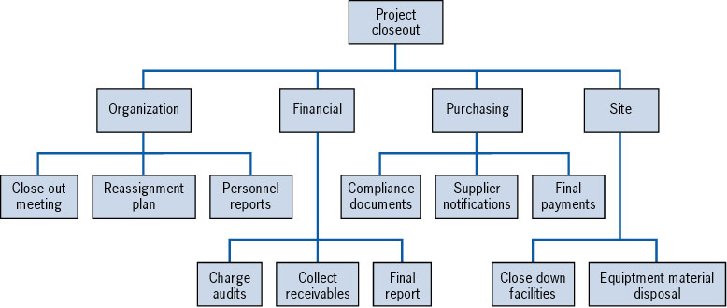

**The Project Final Report**

* Project Performance
  + what was achieved and reasons for resulting performance
* Administrative Performance
  + review of how well administrative practices worked
* Organizational Structure
  + identify modifications to help future projects
* Project Management Techniques
  + recommendations for improvements in future projects

1. **Explain in detail the functional organizational and matrix organizational structure.**

Types of Organizational Structures

**Functional**

The functional structure is based on an organization being divided up into smaller groups with specific tasks or roles. For example, a company could have a group working in information technology, another in marketing and another in finance.

Each department has a manager or director who answers to an executive a level up in the hierarchy who may oversee multiple departments. One such example is a director of marketing who supervises the marketing department and answers to a vice president who is in charge of the marketing, finance and IT divisions.

An advantage of this structure is employees are grouped by skill set and function, allowing them to focus their collective energies on executing their roles as a department.

One of the challenges this structure presents is a lack of inter-departmental communication, with most issues and discussions taking place at the managerial level among individual departments. For example, one department working with another on a project may have different expectations or details for its specific job, which could lead to issues down the road.

In addition, with groups paired by job function, there’s the possibility employees can develop “tunnel vision” — seeing the company solely through the lens of the employee’s job function.

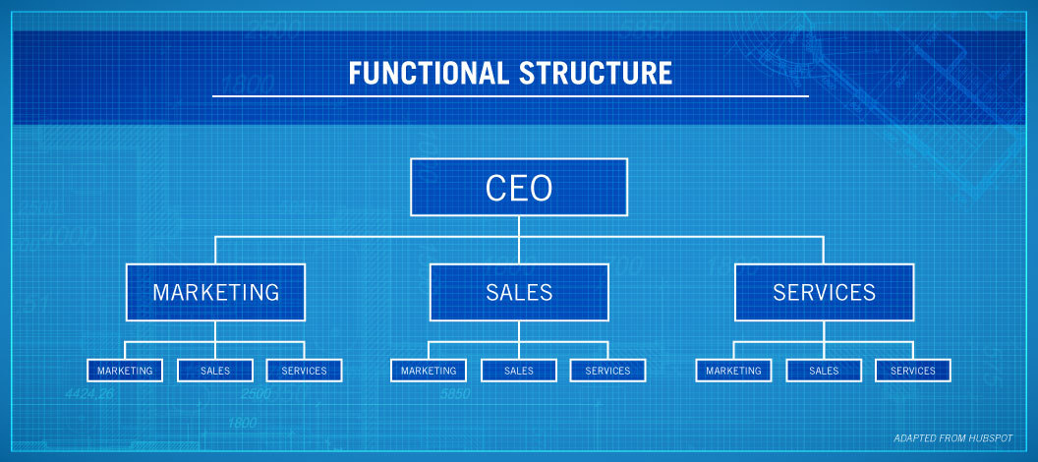

### **Divisional**

Larger companies that operate across several horizontal objectives sometimes use a divisional organizational structure.

This structure allows for much more autonomy among groups within the organization. One example of this is a company like [General Electric](https://www.allbusiness.com/4-common-types-organizational-structures-103745-1.html). GE has many different divisions including aviation, transportation, currents, digital and renewable energy, among others.

Under this structure, each division essentially operates as its own company, controlling its own resources and how much money it spends on certain projects or aspects of the division.

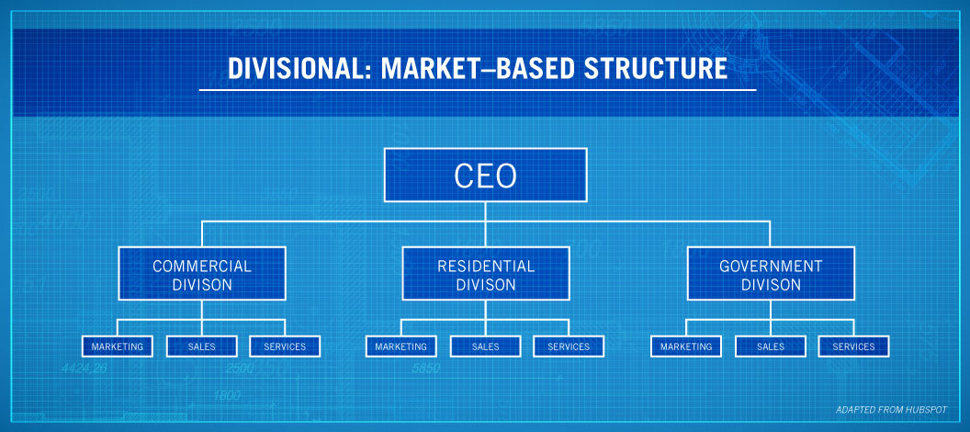

Additionally, within this structure, [divisions could also be created geographically](https://courses.lumenlearning.com/boundless-management/chapter/common-organizational-structures/), with a company having divisions in North America, Europe, East Asia, etc.

This type of structure offers greater flexibility to a large company with many divisions, allowing each one to operate as its own company with one or two people reporting to the parent company’s chief executive officer or upper management staff. Instead of having all programs approved at the very top levels, those questions can be answered at the divisional level.

A downside to this type of organizational structure is that by focusing on divisions, employees working in the same function in different divisions may be unable to communicate well between divisions. This structure also raises issues with accounting practices and may have tax implications.

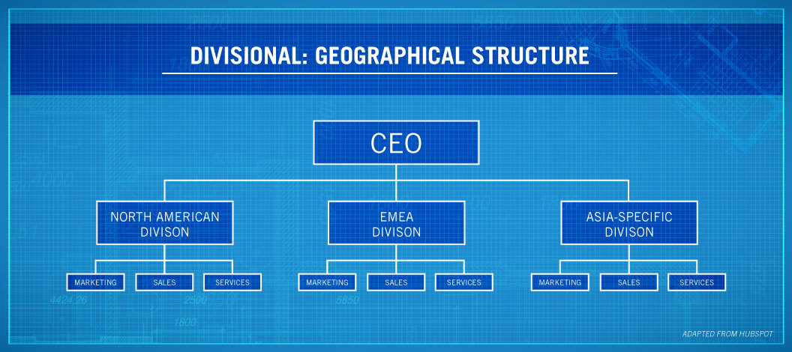

### **Matrix**

A hybrid organizational structure, the matrix structure is a blend of the functional organizational structure and the projectized organizational structure.

In the [matrix structure](https://pmstudycircle.com/2012/08/what-is-a-matrix-organization-structure/), employees may report to two or more bosses depending on the situation or project. For example, under normal functional circumstances, an engineer at a large engineering firm could work for one boss, but a new project may arise where that engineer’s expertise is needed. For the duration of that project, the employee would also report to that project’s manager, as well as his or her boss for all other daily tasks.

The matrix structure is challenging because it can be tough reporting to multiple bosses and knowing what to communicate to them. That’s why it’s very important for the employees to know their roles, responsibilities and work priorities.

Advantages of this structure is that employees can share their knowledge across the different functional divisions, allowing for better communication and understanding of each function’s role. And by working across functions, employees can broaden their skills and knowledge, leading to professional growth within the company.

On the other hand, reporting to multiple managers may add confusion and conflict between managers over what should be reported. And if priorities are not clearly defined, employees, too, may get confused about their roles.

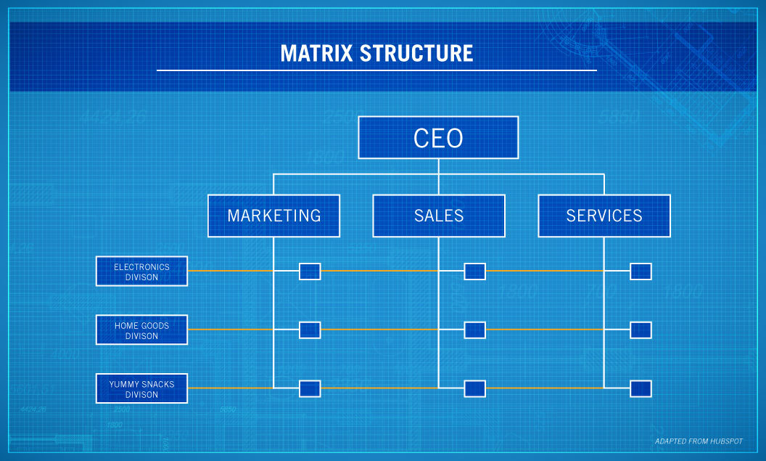

### **Flatarchy**

While the previous three types of organizational structures may work for some organizations, another hybrid organizational structure may be better for startups or small companies.

Blending a functional structure and a flat structure results in a flatarchy organizational structure, which allows for more decision making among the levels of an organization and, overall, flattens out the vertical appearance of a hierarchy.

The best example of this structure within a company is if the organization has an internal incubator or innovation program. Within this system, the company can operate in an existing structure, but employees at any level are encouraged to suggest ideas and run with them, potentially creating new flat teams. Lockheed Martin, [according to Forbes](https://www.forbes.com/sites/jacobmorgan/2015/07/15/the-5-types-of-organizational-structures-part-4-flatarchies/#326b9c1c6707), was famous for its skunkworks project, which helped develop the design of a spy plane.

Google, Adobe, LinkedIn and many other companies have internal incubators where employees are encouraged to be creative and innovative in order to promote the company’s overall growth.

A benefit of this system is it allows for more innovation company-wide, as well as eliminating red tape that could stall innovation in a functional structure. As for the negatives, the structure could be confusing and inconvenient if everyone involved doesn’t agree on how the structure should be organized.